CONFERENCE

CHAMPIONSHIP

CHAMPIONSHIP HOSTING GUIDE

CW staff contacts 3
Introduction/2025-26 dates 4
Championship branding 5
Hosting package 6-7
Office supplied materials 8
Awards 9-10
Webcasting 11
Championship bulletin 12
Sports information 13
Financial 14
Officials 15-16
Miscellaneous 17

CW STAFF

TITLE | NAME | EMAIL | CELL
Managing director | Rocky Olfert | rocky.olfert@canadawest.org | 604-751-1970
Finance Manager | Shauna McLennan | shauna.mclennan@canadawest.org | 403-393-7707
Assoc. Director, Sport | Eoin Colquhoun | eoin.colquhoun@canadawest.org | 403-394-5660
Assoc. Director, Communications & Marketing | Jamin Heller | jamin.heller@canadawest.org | 403-795-6852
Digital Coordinator | Carlo Borella | carlo.borella@canadawest.org | 250-318-5139
Special Projects Coordinator | Melina Ioannides | melina.ioannides@canadawest.org
Statistician | Geoffrey Carr | scores@canadawest.org | 403-922-2024

INTRODUCTION
As part of our commitment to building the Canada West brand, each host must adhere to all Canada West bylaws, policies and playing regulations published as part of the Canada West Operations Manual.

We ask that you take a moment to review the hosting requirements and their applications to each championship event. Besides instructions for hosts and participants, also included are instructions to current possessors of awards, trophies and media backdrops. It is highly recommended that all members review the Operations Manual to familiarize themselves with all policies/regulations as this document is meant to supplement formal policy.

The hosting requirements may incorporate new practices for some of our hosts. We therefore encourage you to contact the Canada West office if you have any questions.

2025-26 CW CHAMPIONSHIP DATES

SPORT CW LOCATION DATE
WOMEN’S RUGBY | University of Alberta | Oct. 16 to 19
GOLF | Chilliwack, B.C. (Hosted by CW) | Oct. 20 to 21
WOMEN’S SOCCER | TBD - highest remaining Pacific Division team | Oct. 31 to Nov. 2
MEN’S SOCCER | TBD - highest remaining Prairie Division team | Oct. 31 to Nov. 2
CROSS COUNTRY | University of Victoria | Oct. 25
FOOTBALL | TBD - highest remaining seed | Nov. 8
SWIMMING | University of Lethbridge | Nov. 28 to 30
WRESTLING | University of Alberta | Feb. 14
CURLING | University of Alberta | Jan. 16 to 18
TRACK & FIELD | University of Saskatchewan | Feb. 20 to 21
WOMEN’S BASKETBALL | TBD - highest remaining seed | Feb. 27 to 28
MEN’S BASKETBALL | TBD - highest remaining seed | Feb. 27 to 28
WOMEN’S HOCKEY | TBD - highest remaining seed | March 6 to 9
MEN’S HOCKEY | TBD - highest remaining seed | March 6 to 8
WOMEN’S VOLLEYBALL | TBD - highest remaining seed | March 6 to 7
MEN’S VOLLEYBALL | TBD - highest remaining seed | March 6 to 7

CHAMPIONSHIP NAMES



Please use the names listed here when referring to Canada West championship events.

Playoff team sports
- 88th BioSteel Hardy Cup
- 2025 Canada West Women’s Rugby Championship
- 2025 Canada West Men’s Soccer Championship
- 2025 Canada West Women’s Soccer Final Four
- 2026 Canada West Men’s/Women’s Basketball Championship
- 2026 Canada West Men’s/Women’s Volleyball Championship
- 2026 Canada West Men’s/Women’s Hockey Final

NOTE: All championship or final events are singular. When referring to the playoffs in each sport, please use the plural. Ie. 2026 Canada West Women’s Hockey Playoffs.

Championship sports
- 2025 Canada West Swimming Championships
- 2026 Canada West Wrestling Championships
- 2026 Canada West Track & Field Championships

NOTE: All events are plural, as the men’s and women’s events are occurring simultaneously, at the same venue.

Other
- 2026 Canada West Women’s Rugby Sevens Championships

LOGOS
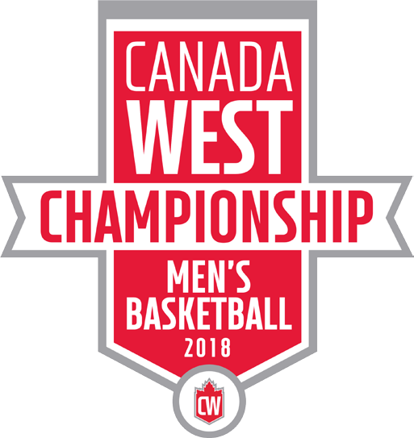

Individual logos have been created for all CW championship events and can be found in the CW Championship folder, within the SID folder on Dropbox.

Canada West championship hosts will be shipped a CW championship hosting package the week of the event. The items listed below will be included in the hosting package, and are expected to be used by the host to showcase the conference brand, as part of the championship.

TABLE COVER & VENUE BANNERS



The table cover displayed is required for use at Canada West championship events.
The table cover is intended to be used at the venue throughout the course of the championship. The cover could be
used on a table near the entrance of the venue (displaying programs etc.), and must be used during the trophy/medal presentation.

The banners displayed (3x6 feet) are required for use at championship events. The banners are intended to be displayed inside the venue (along a railing, on the wall etc.) to showcase the conference brand and differentiate the event from a regular season game.

FEATHER FLAGS
The flags displayed are required for use at CW championship events. The flags are primarily intended to be used
outside the entrance of the host venue, but can also be used inside the venue when applicable.

Each championship host will be shipped two flags (with accompanying hardware) prior to the championship.

Hosts will be required to assure the flags are secured with some form of weight (ie. sand bags etc.).

TABLE COVER


VENUE BANNERS


Hardy Cup specific General championship

CHAMPIONSHIP BACKDROPS

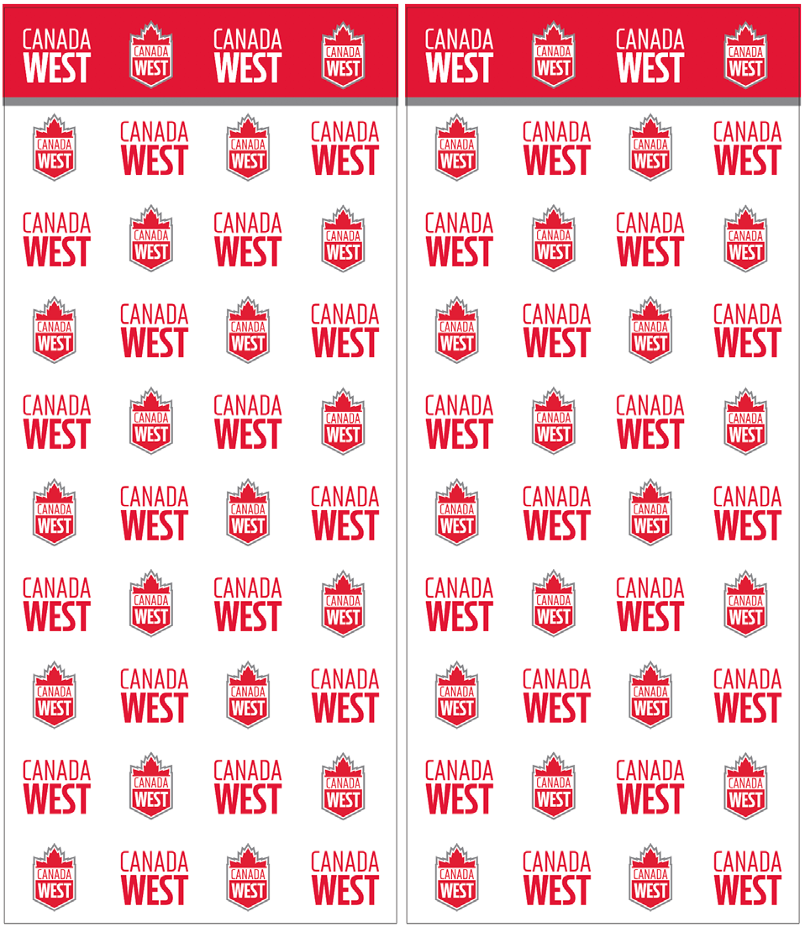
The backdrop displayed is required for use at all CW championship events.
The backdrop should be utilized for the medal/trophy presentations, and media interviews.

The backdrop will be shipped to as part of the hosting package and comes in two panels, each measuring 38.5” wide and 90.5” tall. The panels connect via magnets at both the top and bottom of the panels.

HARDY CUP BACKDROP





















The backdrop displayed is required for use at the Hardy Cup. The backdrop should be utilized for the medal/trophy presentation, and media interviews.



The backdrop will be shipped to members when hosting the Hardy Cup.





MEDALS, BANNERS, & CHAMPIONSHIP TROPHIES

The CW office, in collaboration with our medal and banner supplier Nothers, will provide hosts with both the
CW banner and medals in advance of the championship.

All banners and medals should be at the host a minimum of:
- 14 days prior to the first day of the championship, if host is predeter- mined.
- Tuesday prior to the first day of the championship, if the host is not pre- determined.

All medals should be formally present- ed to the winning teams following the conclusion of play.


The CW championship banner should be formally presented, along with the conference championship trophy, following the conclusion of competition.

The championship trophy will be shipped / brought to the event by the current titleholder. The current titleholder shall advise hosts five days prior to the first day of championships if the trophy will be shipped or brought in.

All trophies must travel in the accompanying travel case. Any damage to the trophy or transit case is the responsibility of the current title holder.

If trophy will be shipped in, the current titleholder must ship it overnight to be received by the host three days prior to the first day of the championships.

INDIVIDUAL AWARDS


When appropriate, CW awards should be presented to any award winners present at a CW championship. Any winners competing in the championship should be acknowledged in the venue over
the PA system either prior to the series commencing, or on the final day of competition.

For the following sports, individualized awards will NOT be available prior to the championship weekend. In the place of an award being presented at any awards ceremony, athletes will receive a letter outlining they will be receiving an individualized plaque in the coming weeks:
- Rugby
- Field hockey
- Track & field
- Cross country
- Wrestling

For all other sports, individualized plaques will be shipped directly to the winner’s athletic department.

NOTE: The letter, which should be individualized by the championship host, can be found in the CW Championship folder, within the SID folder on Dropbox.

CANADA WEST TV
All CW championships must be webcast on Canada West TV. The conference will work with hosts in the weeks leading up to the championship to assure they have all the necessary graphic and video assets required.

Canada West TV must be used for all events in the following sports:

1. Football (men’s)
2. Volleyball (men’s and women’s)
3. Basketball (men’s and women’s)
4. Hockey (men’s and women’s)
5. Soccer (men’s and women’s)
6. Rugby 15s (women’s)
7. Swimming (men’s and women’s)
8. Track and field (men’s and women’s)
9. Wrestling (men’s and women’s)
10. Cross country (men’s and women’s)
11. Curling (men’s and women’s)
12. Field hockey (women’s)
13. Golf (men’s and women’s)
14. Rugby 7s (women’s)

NOTE: Team sports requiring mandatory webcasting of all regular season, playoff, and championship events in bold. Championship sports requiring mandatory webcasting underlined.

All webcast regulations (Policy 12) apply to CW championships.

Members are encouraged to elevate their webcasts for any CW championship events. Hosts should identify any potential issues that will limit their ability to provide a quality webcast well in advance with the CW office, who will work with Visaic and the member to address the shortcomings.

WEBCAST SPONSORSHIP

Canada West retains the rights to all Canada West championship events including title and/or presenting sponsorship and other event sponsorship opportunities. Responsibility for fulfillment and activation is led by the Canada West office, but delivery is shared with applicable member institutions. For tournament sports, the Canada West office must inform the host if there will be championship sponsors a minimum of eight months prior to the championship. Failure to do so will result in the host having the right to sell inventory.

Members are free to place advertising material (commercials, static images, etc.) into webcasts of Canada West championships, so long as they do not conflict with any conference championship sponsors.

CHAMPIONSHIP BULLETIN
Canada West championship hosts must provide participating teams and the conference office with championship details through the distribution of a championship bulletin in advance of the event.

The championship bulletin must include details on the following:
- Organizing committee: position (ex. convener, medical, facility, hospitality, sports info, technical) name, cell numbers, email addresses
- Host hotel: name, address, contact information
- Meeting information (if applicable): coaches meeting date, time, location
- Banquet information (if applicable): date, time, cost, ticket order deadline
- Technical information: competition schedule, venue, locker room assignments, laundry services
- Medical: host medical therapists, supplies, medical coverage
- Sports information: rosters, previews, webcast requests
- Awards: award timelines and presentation details

Please refer to Canada West Policy 13 Appendix B to review all reporting requirements for championship events.

PREVIEW
The CW office is responsible for providing a CW championship preview the week of the event, which includes information on all competing teams, to be completed no later than Wednesday the week of the championship. This will be released on Prezly and posted to the CW website.

RESULTS REPORTING
Hosts must adhere to the conference reporting requirements as per Policy 13 2.2:

Provide CP-style recaps from each game from the following Canada West playoffs and championship events: basketball, football, men’s hockey, women’s hockey, soccer and volleyball. Recaps should follow as soon as possible after the game. (Policy 13 2.3b)

Provide daily CP-style recaps from the following Canada West playoffs and championships: field hock- ey, golf, rugby 15s and 7s, swimming, track & field and wrestling. Recaps should follow as soon as possible after the event.

PHOTOGRAPHY
Canada West Championship hosts must provide a high-quality digital photograph of the winning team (banner/ trophy shot) upon completion of the event to both the CW office and the Sports Information Director of the winning team.

Championship hosts are also required to send 2-3 action photos from the final day of the championship to both the CW office and the Sports Information Director of the winning team. (Policy 13 2.3d)

NOTE: Hosts are encouraged to have a photographer on site for all competition, shooting photos of all competing teams. Host SIDs should communicate with participating SIDs before the competition to inform them of what photo assets will be made available during and after each game.

VIDEO

As per CW Policy 13 Appendix B, hosts must provide a Highlight pack (per game) for football, basketball, volleyball, hockey and soccer.

o Style:
▪ Utilizes CW provided graphics (bumpers)
▪ Quote from the winning team (coach or player)
▪ Neutral (key plays from both teams)
o Length: Minimum of 60 seconds

STATISTICS
Over and above the E-MAILING and POSTING of the appropriate statistical packages, the Canada West host member shall give a copy of the game statistics to the visiting team as soon as possible after the completion of the event. All statistics should be completed within forty-five minutes following the completion of the Canada West event. If issues arise, coaches, the opposing Sports Information Director, and the CW office should be notified immediately that there will be a delay. (Policy 12 2.5.1)

ADMISSION/TICKETS
Hosts will determine ticket prices for CW playoffs. Playoff guarantees are based on a $5.00 admission charge and conservative spectator attendance figures. (Refer to Policy 16 for more information)

PLAYOFF GUARANTEES – Refer to policy 16.5.2.3 for more information.

TRAVEL SUBSIDY
For participating teams in the sports of basketball, football, ice hockey, soccer, and volleyball there is a play- off travel subsidy program in effect.

This is a ‘travel subsidy program’ NOT a ‘total cost recovery program’. This program is further described in the Finance Policy 16 – section 5.

The maximum number of travelling participants that may be claimed under this program is:
- Basketball = 14
- Football = 56
- Ice Hockey = 23
- Soccer = 20
- Volleyball = 16
* Claims are to be based on the actual number of travelling participants.

Please use the CW team playoff travel subsidy form to claim your allowable costs and send it (form with receipts) to the Canada West office within 10 business days following the competition. The postmark date will be used to assess compliance with this requirement. Failure to send the form in within 10 business days will result in a fine. Failure to send the form in with 15 business days may result in forfeiture of the travel portion of the subsidy. Reimbursement will be made at the Canada West AGM.

HOST RESPONSIBILITIES
Officials' playoff game fees are not included in the Best Officials Playoff Program fund. The officials’ game fees will be at the rate generally prevailing in the host province unless otherwise agreed between the CW office, sport convenor and officials assignor. For basketball, the officials’ game fees will be that agreed with the Basketball Panel and Canada West. (Policy 16 5.4.2)

Canada West has agreed to a 'Best Officials’ Playoff Program for the sports of basketball, volleyball, football and ice hockey. This program has been designated as a ‘best officials’ program and not a ‘neutral officials’ program. (Policy 16 5.4) This fund will cover travelling playoff officials’ hotel, meal and transport expenses.

As per Policy 16, 5.4.3, hosts are responsible for:

- Paying officials’ game fees, for which they will be billed, from either the CW office or from the sport’s provincial organization.
- Making all onsite arrangements and paying directly for officials’ accommodations.
  - The host will be reimbursed for hotel accommodations from the Best Officials’ Playoff Fund following the game or series. All claims by hosts for accommodation expenses must be made within ten (10) working days

TRAVEL
This program covers only the travel portion of costs of designated ‘best officials’, which includes:
- Per diems (@ $8 breakfast, $12 lunch, $20 dinner)
- Travel allowance (@ $0.45 per KM)
- Parking
- Tolls
- Hotel accommodations (double occupancy)
- Air fare
- Local transportation

Many of these costs may be submitted by the best official directly to the CW office for reimbursement. For greater clarity, the travel costs do not include game fees of the best officials, which are paid by the host member (either directly to the best official or when invoiced by Canada West).

ACCOMODATIONS
Host members should arrange and pay for double occupancy hotel accommodations for the minimum num- ber of nights required. Officials are to pay for all room incidentals. The host member should be in contact with the sport convenor, CW office and officials’ assignor to confirm responsibility for hotel arrangements.
Preferably, officials should be located at a hotel away from the participating teams.

Unless other arrangements have been made between the host member, the convenor, and the officials’ as- signor, normally the host member is responsible for arranging and paying for local accommodations for the best officials. The host member may then claim for reimbursement from Canada West any costs associated with best officials, other than game fees, within 10 business days following competition may result in either a fine or loss of claim ability or both. The postmark date will be used to assess compliance with this requirement. Failure to send the form in within 10 business days will result in a fine. Reimbursement will be made at the Canada West AGM.

OTHER SPORTS
For sports without best officials programs (soccer, rugby, field hockey, track & field, swimming, wrestling), the host is responsible for all costs associated with securing suitable officials for the event. These costs include, but are not limited to:
- Game fees (per playing regulations)
- Per diems (@ $8 breakfast, $12 lunch, $20 dinner)
- Travel allowance (@ $0.45 per KM)
- Parking
- Tolls
- Hotel accommodations (double occupancy)
- Air fare,
- Local transportation

NOTE: Coordination with the official assignor and/or convenor is recommended.

PLAYOFF SCHEDULE
All playoff formats are predetermined and must be followed. Hosts typically can determine game times (Refer to Policy 8 for more information).

FILM EXCHANGE
The host institution for each post-season series shall be responsible for uploading ALL games hosted by their institution.

The CW office will be responsible for coordinating the upload of the association’s post-season’s schedule with the film exchange service provider.
In season exchanges shall be managed through the conference film exchange service provider. On site exchanges shall be managed in accordance with Policy 11, 4.1 d):
- The visiting team must supply a USB Stick (a minimum of 4GB of space but recommend 8GB) to the host
institution to provide a copy of the first game of the league weekend series within 1-2 hours after the conclusion of the game match. Copies of the second game could also be provided in this format. Hosts are not required to provide the footage in MP4 format.

The host institution for each post-season series, including Final 4, shall be responsible for uploading ALL games host by their institution.

Games must be uploaded by 8:00 am (local time) the day after the game.

Failure to comply with any of the above will result in a fine. See Finance Policy for details on all fines.

PA SCRIPTS
If required, the CW office will provide scripting to hosts to fulfill sponsor/partner recognition. In general, any CW playoff events, and particularly championship events, should be presented in a neutral manner (as opposed to a home event).

If members require further direction on PA scripting for CW championships, templates can be provided by the CW office.

